****St. Paul’s Episcopal Parish**

*822 Washington St. Oregon City, OR 97045*

The Rev. Shawn Dickerson – [Rector](mailto:rector@stpaulsoregoncity.org) + The Rev. Laura Truby – Assisting Priest

Jason Coulthurst – Organist + Jean Wease – [Office](mailto:admin@stpaulsoregoncity.org) Manager

Office Hours: Tuesday-Friday 9am-1pm

503-656-9842 [www.stpaulsoregoncity.org](http://www.stpaulsoregoncity.org)

***Liturgy for Sundays in Easter 2025***

***Rite II - 9:00am***

*This liturgy booklet will be reused until Pentecost.*

***Welcome to St. Paul’s Parish!***

*Gathering together, worshiping God, sharing the journey since 1851.*

*On Easter morning we find the tomb empty? It is not filled with the last wisps of our hope and dreams. Initial confusion ultimately turns to unimaginable joy. The tomb is* ***empty****!! Death has neither consumed our love nor our joy. God has not forsaken us. God is not done. God is doing something new.*

*If you are curious, if you have questions, if you love to sing with joy.....bring your sorrow, your laughter, your love, yourself. Come.*

*Sundays 9:00 am Wednesdays 9:30 am*

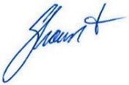

Shawn Dickerson, Parish Priest

**8:55 Bell Rung - Music**

**Welcome, Announcements, Birthdays & Anniversaries**

**Prelude**

**Opening Hymn** *See insert or Hymn Board for number.*

|  |  |
| --- | --- |
| **Liturgy of the Word** | *EOW* **50** |

|  |  |
| --- | --- |
| *Presider:* | Alleluia. Christ is risen. |
| ***People:*** | **The Lord is risen indeed. Alleluia.** |

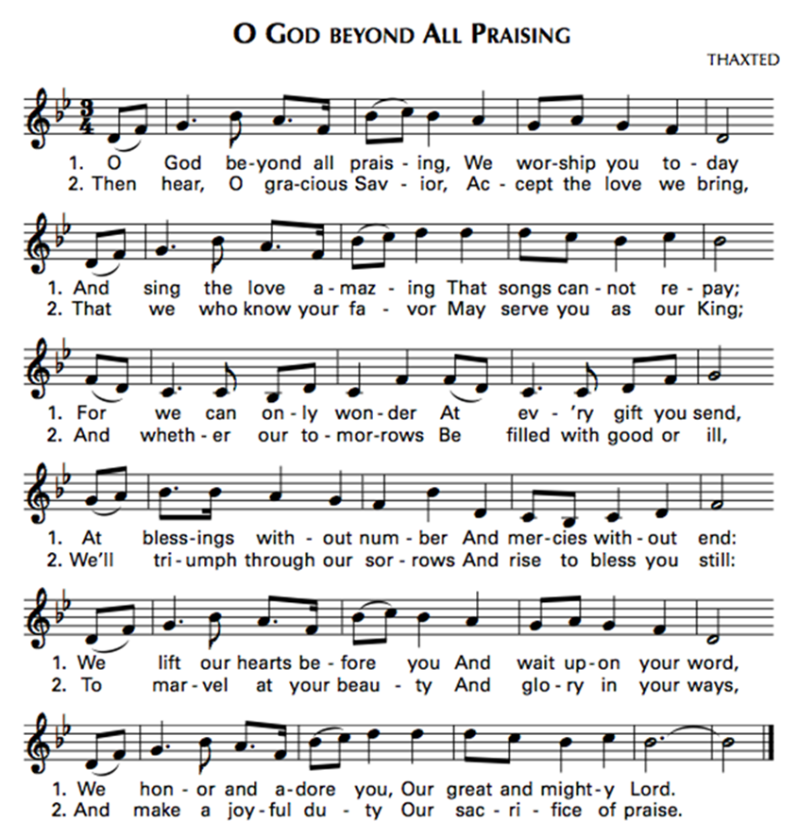Almighty God, to you all hearts are open, all desires known, and from you no secrets are hid: Cleanse the thoughts of our hearts by the inspiration of your Holy Spirit, that we may perfectly love you, and worthily magnify your holy Name; through Christ our Lord.  **Amen.**

***Please continue on page 1 of the insert.***

***+++***

***Turn to page 3 after the sermon.***

|  |  |
| --- | --- |
| **Nicene Creed** | *BCP* **358** |

**We believe in one God, the Father, the Almighty,  
maker of heaven and earth, of all that is, seen and unseen.**

**We believe in one Lord, Jesus Christ, the only Son of God, eternally begotten of the Father, God from God, Light from Light, true God from true God, begotten, not made, of one Being with the Father. Through him all things were made. For us and for our salvation he came down from heaven; by the power of the Holy Spirit he became incarnate from the Virgin Mary, and was made man.  
  
For our sake he was crucified under Pontius Pilate; he suffered death and was buried. On the third day he rose again in accordance with the Scriptures, he ascended into heaven and is seated at the right hand of the Father. He will come again in glory to judge the living and the dead, and his kingdom will have no end.**

**We believe in the Holy Spirit, the Lord, the giver of life, who proceeds from the Father and the Son. With the Father and the Son he is worshiped and glorified. He has spoken through the Prophets.**

**We believe in one holy catholic and apostolic Church.  
We acknowledge one baptism for the forgiveness of sins.  
We look for the resurrection of the dead, and the life of the world to come. Amen.**

**Prayers of the People – Season of Easter**

*People traditionally stand or kneel.*

|  |  |
| --- | --- |
| *Presider:* | In this Easter Season of resurrection and new life, we pray to Father, Son, and Holy Spirit. We give thanks for the wonder and beauty of creation. May our eyes see and our ears hear your blessings in our lives. |
| *Reader:* | For our joys, our longings, our concerns, and our needs – (*moment of silence) -* for your presence in our lives - for hope, encouragement, faith, and the will to continue along The Way.  *(Silence)*  God of new life, |
| ***People:*** | **hear our prayer**. |
| *Reader:* | For our communities where we live, learn, work, and rest - for this parish - for the universal Church – for Donald, our President, Tina our governor, and Denyse our mayor – for our neighbors. May respect, love, and concern rule our hearts.  *(Silence)*  God of new life, |
| ***People:*** | **hear our prayer**. |
| *Reader:* | For our obsession with violence and the threat of violence.  May we find healthy ways to live in your peace.  *(Silence)*  God of new life, |
| ***People:*** | **hear our prayer**. |
| *Reader:* | For generosity between the rich and the poor everywhere. May we share the abundance of your creation.  *(Silence)*  God of new life, |
| ***People:*** | **hear our prayer**. |
| *Reader:* | For growth of love between broken peoples, communities, and nations. May we shape our common life in the image of your kingdom.  *(Silence)*  God of new life, |
| ***People:*** | **hear our prayer**. |
| *Reader:* | For mutual respect between those new to our communities and those who are well established. May we recognize you in all peoples. For protection for the weak and humility for the strong. May we serve others as the body of Christ.  *(Silence)*  God of new life, |
| ***People:*** | **hear our prayer**. |
| *Reader:* | For those who have died *(Silence)*  (especially__________) - trusting they are in your peace and asking you to comfort our sorrow.   *(Silence)*  God of new life, |
| ***People:*** | **hear our prayer**. |

*A moment of silence. Presider adds a concluding collect.*

|  |  |
| --- | --- |
| **Confession** | *EOW* |

|  |  |
| --- | --- |
| *Presider:* | Let us confess our sins to God.  *Silence is kept.* |
| ***All:*** | **God of all mercy, we confess that we have sinned against you, opposing your will in our lives. We have denied your goodness in each other, in ourselves, and in the world you have created. We repent of the evil that enslaves us, the evil we have done, and the evil done on our behalf. Forgive, restore, and strengthen us through our Savior Jesus Christ, that we may abide in your love and serve only your will. Amen.** |
| *Presider:* | Almighty God have mercy on you, forgive you all your sins through the grace of Jesus Christ, strengthen you in all goodness, and by the power of the Holy Spirit keep you in eternal life. |
| ***All:*** | **Amen.** |

**The Exchange of the Peace** *The people greet those near them.*

|  |  |
| --- | --- |
| *Presider:* | The peace of Christ be always with you. |
| ***People:*** | **And also with you.** |

**Offertory Hymn** *See insert or Hymn Board for number.*

*The ushers will collect the offering from the center aisle during the hymn.*

|  |  |
| --- | --- |
| **Presentation Hymn** | *Blue Hymnal* **400 vs. 7** |

**Let all things their creator bless,**

**and worship God in humbleness,**

**O Praise God, Alleluia!**

**Praise God the Father, praise the Son,**

**and praise the Spirit, Three in one:**

**O praise God, O praise God,**

**Alleluia, alleluia, alleluia!**

**Liturgy of the Table ~ The Great Thanksgiving**

|  |  |
| --- | --- |
| **Eucharistic Prayer 2** | *EOW* ***60*** |

*The people traditionally stand.*

|  |  |
| --- | --- |
| *Presider:* | The Lord be with you. |
| ***People:*** | **And also with you.** |
| *Presider:* | Lift up your hearts. |
| ***People:*** | **We lift them to the Lord.** |
| *Presider:* | Let us give thanks to the Lord our God. |
| ***People:*** | **It is right to give God thanks and praise.** |

We praise you and we bless you, holy and gracious God,source of life abundant.From before time you made ready the creation. Your Spirit moved over the deep and brought all things into being: sun, moon, and stars; earth, winds, and waters; every living thing. You made us in your image, and taught us to walk in your ways. But we rebelled against you, and wandered far away; and yet, as a mother cares for her children, you would not forget us. Time and again you called us to live in the fullness of your love. And so this day we join with Saints and Angels in the chorus of praise that rings through eternity, lifting our voices to magnify you as we sing:

|  |  |
| --- | --- |
| **Sanctus** | *Green Hymnal*  **858** |

**Holy, holy, holy Lord,**

**God of power and might,**

**heaven and earth are full of your glory.**

**Hosanna in the highest.**

**Blessed is he who comes in the name of the Lord.**

**Hosanna in the highest.**

**Hosanna in the highest.**

*People traditionally stand or kneel.*

Glory and honor and praise to you, holy and living God. To deliver us from the power of sin and death and to reveal the riches of your grace, you looked with favor upon Mary, your willing servant, that she might conceive and bear a son, Jesus the holy child of God. Living among us, Jesus loved us.

He broke bread with outcasts and sinners, healed the sick, and proclaimed good news to the poor. He yearned to draw all the world to himself yet we were heedless of his call to walk in love. Then, the time came for him to complete upon the cross the sacrifice of his life, and to be glorified by you.

On the night before he died for us, Jesus was at table with his friends. He took bread, gave thanks to you, broke it, and gave it to them, and said: “Take, eat: This is my Body, which is given for you. Do this for the remembrance of me.”

As supper was ending, Jesus took the cup of wine. Again, he gave thanks to you, gave it to them, and said: “Drink this, all of you: This is my Blood of the new Covenant, which is poured out for you and for all for the forgiveness of sins. Whenever you drink it, do this for the remembrance of me.”

Now gathered at your table, O God of all creation, and remembering Christ, crucified and risen, who was and is and is to come, we offer to you our gifts of bread and wine, and ourselves, a living sacrifice. Pour out your Spirit upon these gifts that they may be the Body and Blood of Christ. Breathe your Spirit over the whole earth and make us your new creation, the Body of Christ given for the world you have made.

In the fullness of time bring us, with Paul, Mary Magdalene, and all your saints, from every tribe and language and people and nation, to feast at the banquet prepared from the foundation of the world. Through Christ and with Christ and in Christ, in the unity of the Holy Spirit, to you be honor, glory, and praise, for ever and ever. **AMEN.**

*And now, as our Savior Christ has taught us, we are bold to pray,*

**Our Father, who art in heaven, hallowed be thy Name,**

**thy kingdom come, thy will be done, on earth as it is in heaven.**

**Give us this day our daily bread.**

**And forgive us our trespasses, as we forgive those who trespass against us.**

**And lead us not into temptation, but deliver us from evil.**

**For thine is the kingdom, and the power, and the glory, for ever and ever. Amen.**

**Breaking of the Bread**

*The bread is broken. Silence is kept.*

|  |  |
| --- | --- |
| **Fraction Anthem** | *Green Hymnal*  **876** |

*Antiphon:* **The disciples knew the Lord Jesus**

**in the breaking of the bread.**

**1. The bread which we break, Alleluia,**

**is the communion of the Body of Christ.**

**2. One body are we, Alleluia,**

**for though many we share one bread.**

*All baptized are welcome and invited to receive communion at the railing. If you would like a blessing, fold your arms across your chest. We are happy to bring communion to you. Gluten-free bread is available. The cup is sanitized with alcohol between each person.*

**Communion Hymn** *See insert or Hymn Board for number.*

|  |  |
| --- | --- |
| **Post Communion Prayer** | *EOW* ***70*** |

|  |  |
| --- | --- |
| *Presider:* | Let us pray. |
| ***People:*** | **Loving God, we give you thanks for restoring us in your image and nourishing us with spiritual food in the Sacrament of Christ’s Body and Blood. Now send us forth a people, forgiven, healed, renewed; that we may proclaim your love to the world and continue in the risen life of Christ our Savior. Amen.** |

**Blessing**

**Closing Hymn** *See insert or Hymn Board for number.*

**Dismissal**

|  |  |
| --- | --- |
| *Presider:* | Let us go forth in the name of Christ. Alleluia. Alleluia. |
| ***People:*** | **Thanks be to God. Alleluia. Alleluia.** |

**Postlude**

**Coffee Hour & Forum**

*All are invited to gather in the Parish Hall following this worship service for coffee and fellowship.*

*Forum meets in the Kelly Room when bell rings during coffee time, about 10:15.*

**Postlude**

**Liturgical Notes**

* One license #718976.
* EOW-Enriching Our Worship Church Publishing 1998.
* BCP-Book of Common Prayer 1979
* Prayers of the People-written by S. Dickerson+
* This service is streamed live and recorded on our YouTube channel. To view, begin at our website www.stpauloregoncity.org and click the link to our YouTube channel.